/* The following program will compile and run, but it uses poor programming style.
Modify the program so that it uses the recommended spelling conventions,
constant naming conventions, and formatting style.

public class messy {
public static void main(String[] args)
{
double TIME; double PACE;
System.out.println("This program calculates your pace given a time and distance traveled.");
TIME = 35.5;
PACE = TIME / distance;
System.out.println("Your pace is " + PACE + " miles per hour.");
}
public static final double distance = 6.21;
} */

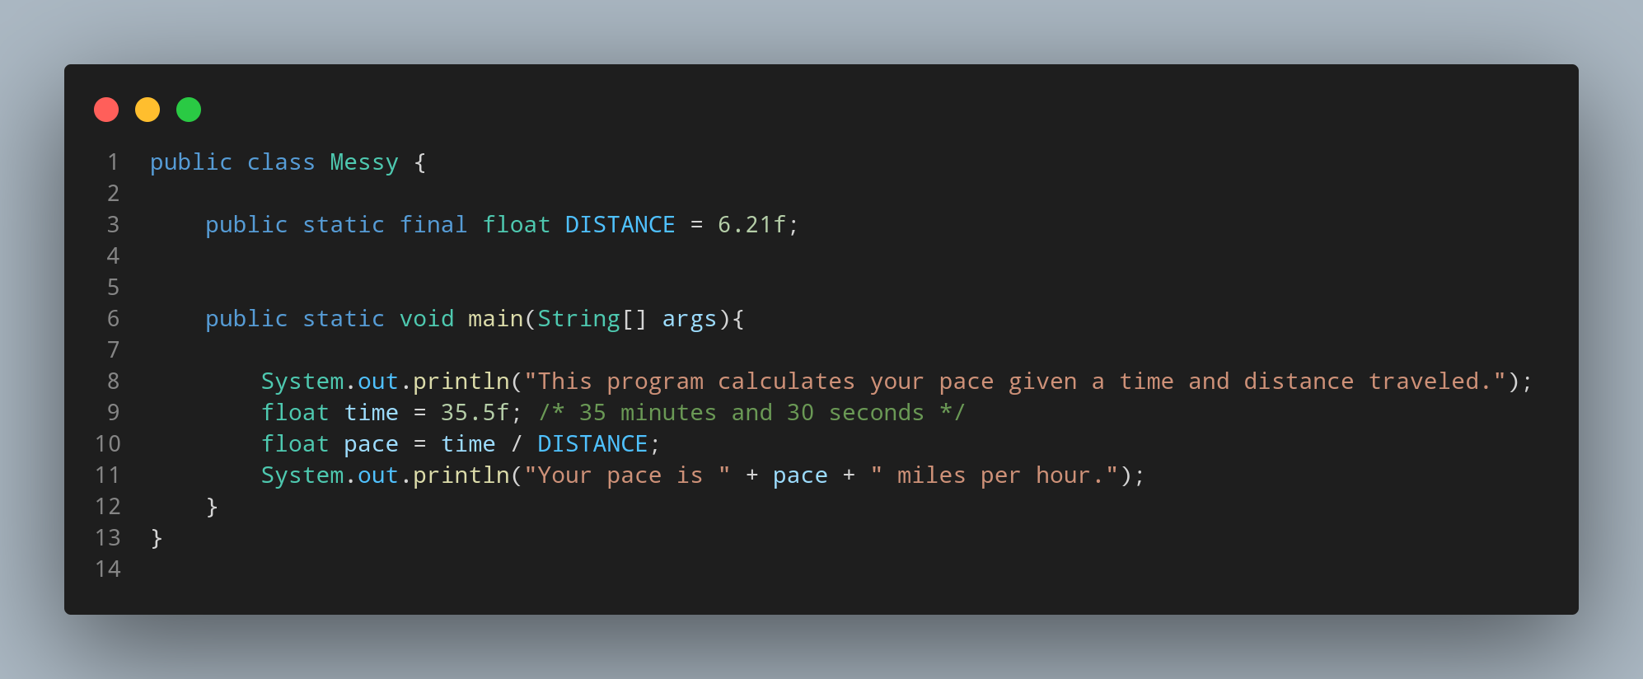

#Doc

rather than explaining the code I’ll explain what were the mistake in given question program and how I find out thw solution.

• public class messy{}

In above code we are creating a class but naming calss is a bit incorrect in above program. For solution The first letter of class name → public class Messy{}.

• public static final double distance = 6.21;

In above code we created constant but again naming style doesnor match the standard style , for constant naming must be all in capital letters → public static final float DISTANCE = 6.21f;

• double TIME; double PACE;

In above we created a variable , and name for variable is camel convection so for the one word every letter must be small letter and changed data type as decimal value were small for double data type (optional). → float time = 35.5f;

• float pace = time / DISTANCE;

Same as point 3

